NHS Excess Treatment Cost Guidance

Secondary Care

Contents
Section 1 | Background and Eligibility | 3
Section 2 | The Application Process | 5
Section 3 | Treatment Costs Template | 6
Section 4 | Submitting your application | 7
Appendix 1 | Attribution of funding for research grants | 9
Appendix 2 | Flow chart for support funding available | 10

1. Background and Eligibility
1.1 This document provides guidance on applying to the Health and Care Research Wales Support Centre for funding to cover the Excess Treatment Costs (ETCs) of externally funded non-commercial research in Secondary Care undertaken in NHS Wales.
1.2 In order to assess and attribute the costs of a research project correctly, you will need to read the ‘Attributing the costs of Health and Social Care Research and Development (AcoRD) guidance document available here. This guidance is also in place in England, Northern Ireland and Scotland. AcoRD provides a framework for the identification, attribution and, where relevant, recovery of the various costs associated with research in the NHS, in a transparent, robust and consistent manner.
1.3 Clarification is also provided between the three categories of costs associated with non-commercial research studies:
1.3.1 Research Costs
1.3.2 NHS Support Costs
1.3.3 NHS Treatment Costs
Please see Appendix 1 for a brief overview of the attribution process.
1.4 If an activity is integral to the provision of a treatment regime, whether this is standard or experimental, then it is attributed as a NHS Treatment Cost. In order to decide whether a study has treatment costs and potentially ETCs, you should refer to the AcoRD guidance.
1.5 Types of activities that are attributed to NHS Treatment Costs include:
1.5.1 Supplying and administering the medicine/device/therapy being studied
1.5.2 Supplying and administering any active comparators – including medicines, devices or therapies, but not placebo or sham treatments
1.5.3 Training of NHS staff to deliver the treatments
1.5.4 Investigations and tests which would continue to be incurred if the patient care service in question continued to be provided after the R&D study has stopped
1.5.5 Patient follow-up where this is required as part of the clinical management of a patient and will be part of the treatment if the intervention being tested becomes part of standard care.
1.6 During a research study, the associated NHS Treatment Costs of the intervention arm(s) may be less, or may be greater, than the cost of standard treatment. If greater, the difference between the cost of the study intervention and the cost of the standard treatment is referred to as Excess Treatment Costs.
1.7 NHS Treatment costs associated with research studies are the responsibility of the NHS and should be funded through the normal commissioning process. The funding to cover Excess Treatment Costs can be accessed through a centrally managed process in Wales. This centrally managed funding process is the responsibility of the Health and Care Research Wales Support Centre. Health and Care Research Wales is a national, multi-faceted, virtual organisation funded and is overseen by the Welsh Governments’ Research and Development (R&D) Division. It provides an infrastructure to support and increase capacity in R&D, runs a range of responsive funding schemes and manages the Support and Delivery centralised funding allocation.
1.8 Neither the NHS organisations nor the Health and Care Research Wales Support Centre will fund non-NHS Treatment Costs i.e. the cost of interventions that if put into practice at the end of the study would be met from non-NHS funding bodies such as social care or education.
1.9 ETC funding is only available for studies that are eligible for adoption to the Health and Care Research Wales Clinical Research Portfolio. A list of research funders who are considered eligible funders and will automatically be adopted onto the Clinical Research Portfolio can be found on the Health and Care Research Wales website here.
1.10 ETC applications will be considered once research grant funding has been awarded. Health and Care Research Wales Support Centre does not provide an offer of ETC funding (even a letter in principle) prior to grant award. Once the research grant is awarded, Health and Care Research Wales Support Centre is committed to providing the funding to meet the ETC, provided the funding within the ETC budget is available.
Appendix 2 shows a brief overview of the process and timing of the ETC funding scheme.
1.11 Excess Treatment Costs will not be covered for:
1.11.1 commercial research undertaken on behalf of pharmaceutical or other companies, or for the researcher's own personal commercial interests (except where a commercial company provides a contribution to the NHS costs of the research, for example by free provision of a drug, and the majority of the research costs are met by one of the research funders covered in paragraph 1.9).
1.11.2 research where the R&D costs are funded by NHS Health Boards and Trusts, or Trustee or other charitable funds held by or on behalf of one or more of the above, whether directly or through a separate charity or university; and
1.11.3 costs associated with services to private patients undertaken by NHS Providers.
1.12 For commercial research, the commercial organisation should meet the full NHS costs of the research.
1.13 Applicants are strongly advised to discuss studies with the local NHS R&D office at an early stage and throughout study development prior to submission to the Health and Care Research Wales Support Centre.
1.14 Applications for an ETC cannot be submitted for costs incurred prior to the submission of the application.
1.15 If an ETC is required for centres outside of Wales for a Wales-led study, there are separate arrangements in place for applying for an ETC in England, Scotland and Northern Ireland.
1.16 NHS organisations or researchers via the appropriate NHS R&D office can apply for an ETC whilst undertaking other Research Support and Governance processes such as processing R&D permissions.

2. The Application Process
2.1 The Excess Treatment Cost Application form should be completed by the Chief Investigator or Principal Investigator in collaboration with the NHS R&D office. It is acknowledged that Clinical Trials Units are also involved in costing studies and will also be involved in attributing and costing studies as part of grant application development.
2.2 The details given on this form are used to evidence the need for the funding of your ETC. Please be clear and concise in what you are requesting, and importantly, realistic in your assumptions regarding recruitment rates and spending times scales. Funding is not always available to move from one financial year to the next.

2.3 Completing the Excess Treatment Costs Application Form
On the front page we require:
Study Acronym | To be used in all correspondence
Funding amount requested | This is the total ETC amount you require for the whole study
Contact details | In the event of a query this is the person the Support Centre will contact to gain information

2.4 Section 1 - Study Information
Full study name | Full title of study
Sponsor | sponsoring organisation of the study
CPMS or IRAS number | The unique reference number taken from the CPMS or IRAS database. Used to show the study has been officially accepted onto the Clinical Research Portfolio
Grant Funder | Who has supplied the study grant
Grant award date | Initial date study grant was awarded
Total grant award | The total amount of grant funding awarded to the study
Study details – location | Please list here the hospitals or practices in which the study is expected to take place including the health board involved. TO NOTE: For funding allocation reasons, the Support Centre requires an ETC application per health board, therefore if this is a multi-site study we would expect an ETC application to be completed per health board. Activities/Interventions attributed as ETCs should be consistent across multicentre/sites and if possible calculated on a consistent basis across centre/sites

2.5 Section 2 - Study team information
Please list the full details of the study Chief Investigator, the Principal Investigator if the CI is not based in Wales. The nominated contact which includes further details of the contact details listed on the front page, and the NHS R&D office contact.
2.6 Section 3 - Study details
Start date and expected end date of the study | Start and end date of the whole study required, and the proposed start and end date of when ETC costs will be incurred. It is very important that this date is realistic as the Support Centre will profile the finances using these dates. Errors here may result in a loss of support funding as the Support Centre cannot guarantee unspent funds can be moved to the next financial year. This will result in the NHS health Board not being able to recover the funds and would be detrimental to the study and all future studies
Study Outline | This should be brief and concise and written with the aim that a non-medical or scientific reviewer will be reading this and assessing your application on their understanding

2.7 Section 4 - Details of Costs Requested
2.8 The ‘Treatment Costs Template’ is a separate spreadsheet and should be completed by the Chief Investigator or Principal Investigator (CI or PI) in collaboration with the NHS R&D office a contact list is available here
2.9 Details are required for the intervention/experimental arm(s) of the study and for the relevant standard care arm. We do not require Control arm costs.

2.10 Excess Treatment Costing Template
Instructions tab | Here you will find a short description of the information we require from you in terms of ETC finances for your study
Summary tab | This table will automatically be populated from the intervention arm tabs. The information here will be used to create the funding profile across the life of the study
Standard Care Costs | Here you need only complete the cells that are highlighted in yellow
Intervention Arm Costs | Here you need only complete the highlighted cells. Please include the study title and who the template is being completed by (only in Arm A Costs)
 | On the right of the template please specify the number of patients and length of study in years. Of key importance is the expected participants per year as this is used in calculating the funding per year of your ETC. Submitting a linear recruitment rate may lead to funds being lost if your patient recruitment is not linear
Staff Resources | Those relating to treatment costs, should be presented in terms of an hourly rate and number of hours required per participant. The hourly rate can be found in standard NHS cost tariffs here, these tariffs should be used in calculating the standard care costs and the interventional treatment costs in the interventional/ experimental arms.  If the application is being made as the lead site for the study in Wales, consideration must be given to the drug costs across all sites, rather than at just one specific site. The cost must most closely reflect what the NHS is currently paying for the drug or intervention in question

2.11 Section 5 - Details of Costs requested
Declaration and Signature | The ETC application will need to be signed and dated by the lead investigator and the NHS R&D Manager or Director from the health board in which the study is taking place. If this is a multi-site study, please duplicate the R&D Manager section for sign off from all health boards involved or supply confirmation emails from signatories.

3. Submitting your application
3.1 Once the R&D Manager or Director is satisfied that the information is accurate, the ETC Application Form must be submitted to Health and Care Research Wales Support Centre by the NHS R&D office on behalf of their Chief Investigator or Principal Investigator.
3.2 If a study involves more than one NHS organisation, Health and Care Research Wales Support Centre will allow one NHS organisation to lead and complete one form for all sites but please include an Excess Treatment Costing template for each health board. If the standard care costs are the same across all health boards then please complete 1 Excess Treatment Costing template which an authority per tab.
3.3 The ETC Application Form should be accompanied by the following:
1. Completed ETC template
2. Most recent approved study protocol
3. Patient Information Sheet (if available)
4. If applicable, a copy of any letters providing decisions on ETCs in England, Scotland, or Northern Ireland
3.4 An electronic copy with a scanned ‘wet signature’ from the NHS R&D Manager or Director should be sent to Research-FundingSupport@wales.nhs.uk
3.5 Any questions should be directed in the first instance to the relevant local NHS R&D office in your NHS Health Board or Trust. Contact information is available here.
3.6 Once submitted the Health and Care Research Wales Support Centre will process your application, providing a decision to you within 10 working days. Our process is shown below.

Appendix 1: Attribution of funding for research grants
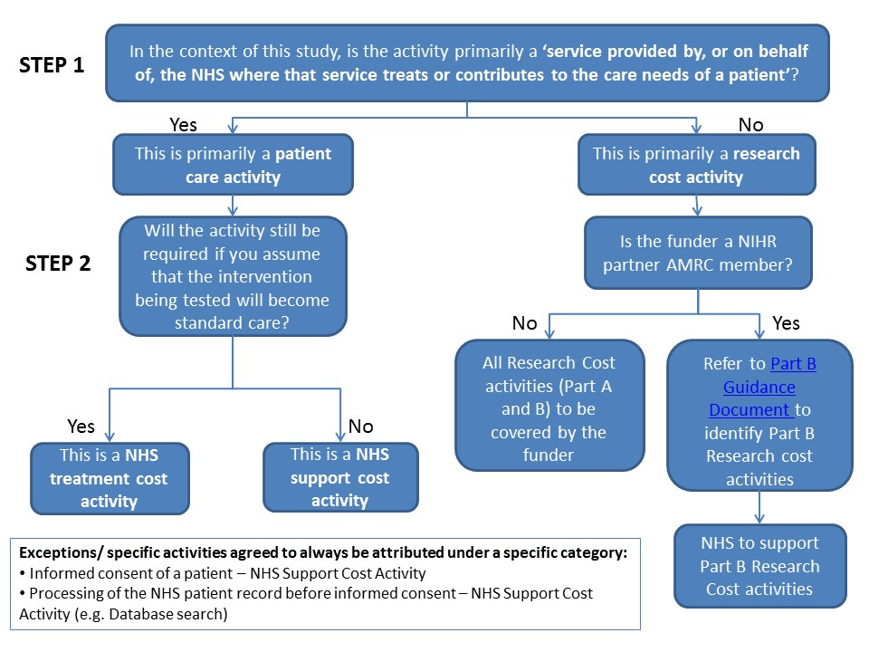
Appendix 2