Attributing the costs of Health and Social Care Research & Development

(AcoRD)

Updated November 2017
Contents

Contents 2
Purpose 3
Background 3
Basic Principles 4
Commercial Contract Studies 4
Non-commercial Studies 5
The Attribution Process 6
Exemplar Lists 8
Annex A List of common research activities attributed to the Research Costs, NHS Treatment Costs and NHS Support Costs
Annex B List of Frequently Asked Questions

Purpose
Health & social care research is a core NHS activity and as such, the NHS is committed to supporting a portfolio of commercially and non-commercially funded research. This guidance provides a transparent and consistent basis for attributing the costs of health and social care research studies.
Background
1.1 Research should be viewed as a core function of the NHS and the NHS throughout the UK is committed to promoting and conducting research to improve current and future health and social wellbeing and to improve NHS patient care services. Whilst the NHS must play its full part in supporting research, it is important that the cost of that research is identified and properly funded.
1.2 This guidance provides a framework for the NHS and its partners to identify, attribute and recover the various costs associated with research in the NHS, in a transparent, robust and consistent manner. It applies to all NHS research covered by the Research Governance Framework for Health and Social Care. While there are differences in certain aspects of the funding mechanisms operating in England, Northern Ireland, Scotland and Wales, including the provision of research infrastructure, the principles of cost attribution set out in this note are common to all four nations. Each country have different accompanying Frequently Asked Questions (FAQs) documents to reflect the different infrastructures.
1.3 This guidance builds on the original HSG (97)32: Responsibilities for meeting Patient Care Costs associated with Research and Development in the NHS but replaces the Attributing Revenue Costs of externally funded non-commercial research in the NHS (ARCO) 2005 document. The new guidance reflects significant change in the research landscape over recent years. The revised attribution process places more emphasis on the primary purpose of an activity and less on where that activity takes place or on who undertakes an activity. It is recognised that, in some instances, the clarification provided by this guidance may result in changes to previous cost attribution practice. The Health Departments will monitor the impact of this new guidance to ensure there are no unforeseen consequences.
Basic Principles
2.1 Research studies comprise of a number of component activities, which, for the purpose of agreeing funding arrangements, are attributed to one of three broad cost categories:
• Research Costs - the costs of the R&D itself that end when the research ends. They relate to activities that are being undertaken to answer the research questions.
• NHS Treatment Costs - the patient care costs, which would continue to be incurred if the patient care service in question continued to be provided after the R&D study had stopped.
• NHS Support Costs - the additional patient care costs associated with the research, which would end once the R&D study in question had stopped, even if the patient care involved continued to be provided.

2.2 While cost attribution follows clear principles, the application of those principles in complex clinical circumstances, can be challenging. Equally, the potential challenge of recovering attributed costs is also acknowledged. The funding of non-commercial research frequently involves a number of partner organisations who collaborate to support and undertake clinical research. This may introduce a greater degree of complexity than is encountered in commercially funded research where the relationship between cost attribution and cost-recovery is more absolute. While the four Health Departments expect non-commercial funding partners to respect the outcomes of the cost attribution process, it recognises that there may be specific circumstances that require compromise and, in some instances, the adoption of pragmatic solutions to cost recovery. Annexes A and B distinguish degrees of flexibility that reflect the different research support/infrastructure initiatives individual countries have pursued.
Commercial Contract Studies
2.3 The funding arrangements for commercial contract research studies are straightforward. The NHS is required to recover from industry, all costs over and above the standard NHS Treatment Cost. The attribution of costs is therefore, not an issue for commercial contract research.
2.4 To further simplify the process of cost recovery, industry costing templates have been developed to provide transparency, greater consistency and predictability in deriving research study costs. A variety of industry costing templates, based on the principles of the NHS Finance Manual, are available for commercial contract research undertaken in the NHS involving pharmaceutical clinical trials, biotechnology agents, and medical devices. Specific templates are also available for NHS primary and secondary care settings. Further information is available on industry costing templates at https://www.nihr.ac.uk/funding-and-support/study-support-service/early-contact-and-engagement/commercial-study-costing-templates.htm.
2.5 Although initially developed for studies intended for adoption by the Clinical Research Networks in England, the templates are freely available to companies interested in running trials anywhere in the NHS and their use is recommended by the four Health Departments of the United Kingdom for commercial contract studies involving the NHS. Given the success of the commercial costing templates, the possibility of developing equivalent non-commercial costing templates is being explored.
2.6 It is important to note research studies are not automatically considered to be ‘commercial contract research’ simply because they attract industry funding. Commercial companies also work collaboratively with NHS bodies or non-NHS research funders to support non-commercial research. If a study is primarily for the public benefit, rather than direct commercial benefit of the company concerned, it may be considered non-commercial. Specific guidance on NHS collaboration with commercial companies is available on the National Institute for Health Research website at https://www.nihr.ac.uk/life-sciences-industry/.
Non-Commercial Studies
2.7 In comparison with commercially contracted NHS research, the funding arrangements for non-commercial NHS research can be more complex, often involving a number of partner organisations. It is essential that both the NHS and its partner organisations identify and quantify the full cost of non-commercial research and reach a shared understanding of how these costs are recovered through appropriate funding arrangements.
2.8 For non-commercial studies the normal funding arrangements for research, NHS Treatment and NHS Support Costs are:
• Research Costs - are usually met by grant funders through the award of a research grant. However, there are some specific research activities where, in Wales, the costs will be met by the Department of Health. These are outlined in Annexes A and B.
• NHS Treatment Costs - met through the normal commissioning process. Annex B outlines the arrangements in Wales.
• NHS Support Costs - met from the R&D budget by the Health Departments of the United Kingdom - see Annexes.

The Attribution Process
3.1 The application of the cost definitions, set out in paragraph 2.1 above, has over time led to divergence in interpretation and practice. The following section provides revised guidance on the attribution process and is augmented by exemplar lists of common research related activities attributed to each of the three cost categories. These lists (Annex A) are not exhaustive and are intended to assist interested parties to understand the attribution process.
3.2 The attribution decision for a specific research-related activity is driven by the primary purpose of the activity but must also recognise the context within which the activity takes place.
3.3 To help arrive at the correct attribution decision and to help differentiate between these cost categories it is helpful to refer to the concept of NHS patient care services and the premise that the NHS bears the cost of caring for its patients even when they are involved in a research study. This may provide a more intuitive approach to cost attribution.
3.4 NHS patient care service is defined as ’a service provided by, or on behalf of, the NHS where that service treats, or contributes to, the care needs of a patient’. The service may include all types of patient care services, including diagnostic, preventive, therapeutic, continuing-care and rehabilitative-care services, as well as health promotion. It also includes activity that measures or monitors the health of a patient receiving an experimental treatment regime where that activity is assuring the safety of the patient.
3.5 A two-step approach to cost attribution is recommended. The first step differentiates between Research Costs and the costs of NHS patient care services. The second splits NHS patient care services into NHS Treatment Costs and NHS Support Costs. An overview of this two-step process is provided in Figure 1.
3.6 Step 1 - Research Costs are derived from the core research activities that are being undertaken to answer the research question(s). They end when the research ends. In practice, it is easier to identify Research Costs by exclusion. If an activity is not directly contributing to a NHS patient care service then it is attributed as a Research Cost. Annex A provides a list of common research activities that fall into the Research Cost category. Where the grant funder is a member of the Association of Medical Research Charities (AMRC), Research Costs must be further attributed between those activities that fall within Part A of Annex A and those that fall within Part B.
3.7 Step 2 - Activity that is regarded as part of a NHS patient care service must be split between NHS Treatment Costs and NHS Support Costs.
3.8 The differentiation between these two categories is again driven by primary purpose. If an activity is integral to the provision of a treatment regime, whether this is standard or experimental, then it is attributed as a NHS Treatment Cost. If a patient care activity is primarily undertaken to facilitate research or is driven by the NHS duty of care to a patient, e.g. to ensure the safety of a patient participating in research then it is attributed as a NHS Support Cost. Annex A provides a list of common research activities that fall into NHS Treatment Costs and NHS Support Costs categories.
3.9 A research study may result in a NHS patient care service that differs from standard treatment, or is delivered in a different location from where it would normally be given. The associated NHS Treatment Costs may be less, or may be greater, than the cost of standard treatment. If greater, the difference between the NHS Treatment Costs and the cost of the standard treatment is referred to as the NHS Excess Treatment Costs. These excess costs are nonetheless part of the NHS Treatment Costs, not an NHS Support Cost and are not normally funded from NHS R&D budgets. However, there are country-specific arrangements in place across the United Kingdom to provide some subvention support from departmental R&D budgets. These arrangements are outlined in the FAQs.

Figure 1: Funding attribution flowchart

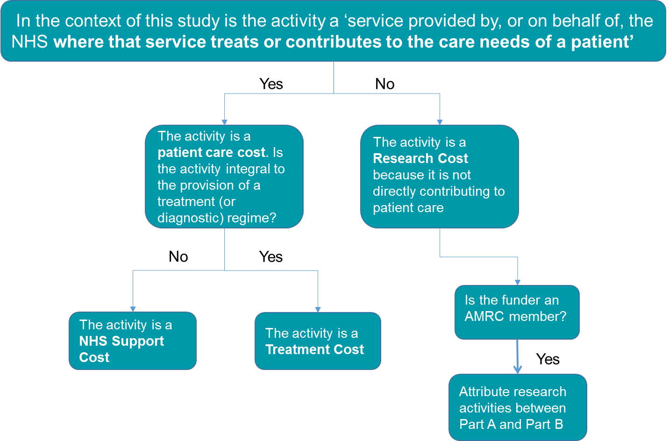

Exemplar Lists
3.10 The exemplar lists (Annex A) of common research activities attributed to the Research Costs, NHS Treatment Costs and NHS Support Costs categories are intended to help explain the attribution process and the underlying rationale. While these lists attempt to encompass the common research activities they can never be exhaustive. As considerable reliance may be placed on these lists they will be augmented as experience in implementing this guidance is gained and they will be provided online alongside the FAQs document (Annex B). Users are advised to always refer to the up-to-date version of this document.
3.11 It is apparent from the exemplar lists that investigations, assessments or tests present a group of activities that maybe attributed as Research Costs, NHS Treatment Costs or NHS Support Costs. Indeed the same activity (e.g. blood pressure reading) may, in a single research study, fall into all three cost categories depending on the primary purpose of undertaking the activity at a specific point in the research study. Therefore, the primary purpose of an investigation, assessment or test must be carefully considered and explained in the research protocol to facilitate correct attribution.
3.12 Where the primary purpose of an activity is to generate data to answer the research question then the activity is not primarily concerned with patient care and is regarded as a Research Cost even where it is a clinical activity. The split between NHS Treatment Costs and NHS Support Costs is, in some instances, less obvious. Both provide different aspects of a NHS patient care service. However, a key delineator is the residual consequence arising from the cessation of a research study. NHS Treatment Costs would continue to be incurred as long as the treatment regime continued to be delivered; extending beyond the completion or cessation of the particular research study. In contrast, NHS Support Costs would cease with the completion or cessation of the research study as they are not an integral part of the treatment regime. For the purposes of the attribution process it can be assumed that an experimental intervention/service being tested will continue after the end of the study.
3.13 The rationale of using primary purpose to determine the attribution of research activity therefore raises the possibility that an individual involved in a research study, a research nurse for example, may carry out a range of activities some of which will be Research Costs, some will be NHS Support Costs and some will be NHS Treatment Costs. The funds required to cover the cost of this one member of staff may therefore need to come from a range of funding sources.
3.14 NHS research is increasingly complex and challenging. It may involve a variety of people and a variety of organisations. Attempts to classify research activity inevitably impose what must always be an artificial classification on a real world situation. Therefore no matter how elaborate the classification system it can never accommodate every reality. There is often a need to compromise and the particular circumstances of individual research studies need to be considered within the overall classification rationale set out in this guidance note.
3.15 As previously explained Annex A and B are published separately so that they can be updated and published on the internet on a regular basis, to provide more specific guidance/context.

