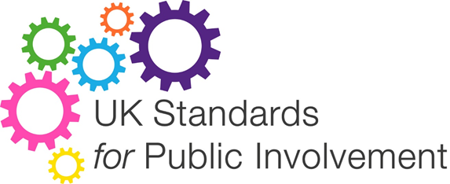

Training workbook

To accompany the training package for Wales 2020

Reflective Questions as published in UK Standards for Public Involvement November 2019

It is important to complete the feedback on page 9
in order to be sent a certificate

Inclusive Opportunities

Offer public involvement opportunities that are accessible and that reach people and groups according to research needs.

Research to be informed by a diversity of public experience and insight, so that it leads to treatments and services which reflect these needs.

The questions below may help you reflect on and decide if you meet the standard:

Are people affected by and interested in the research involved from the earliest stages?
Fill your answer in this space:

Have barriers to involvement, such as payment for time or accessible locations for meetings been identified and addressed?
Fill your answer in this space:

How is information about opportunities shared, and does it appeal to different communities?
Fill your answer in this space:

Are there fair and transparent processes for involving the public in research, and do they reflect equality and diversity duties?
Fill your answer in this space:

Is there choice and flexibility in opportunities offered to the public?
Fill your answer in this space:

Working Together

Work together in a way that values all contributions, and that builds and sustains mutually respectful and productive relationships.

Public involvement in research is better when people work together towards a common purpose, and different perspectives are respected.

The questions below may help you reflect on and decide if you meet the standard:

Has the purpose of public involvement been jointly defined and recorded?
Fill your answer in this space:

Have the practical requirements and arrangements for working together been addressed?
Fill your answer in this space:

Have all the potential different ways of working together been explored, and have these plans and activities been developed together?
Fill your answer in this space:

Is there is a shared understanding of roles, responsibilities and expectations of public involvement?
Fill your answer in this space:

Have individuals’ influence, ideas and contributions’ been recognised and addressed?
Fill your answer in this space:

Support and Learning

Offer and promote support and learning opportunities that build confidence and skills for public involvement in research.

Remove practical and social barriers that stop members of the public and research professionals from making the most of public involvement in research.

The questions below may help you reflect on and decide if you meet the standard:

Is there a range of support to address identified needs?
Fill your answer in this space:

Have specific resources been designated to support learning and development opportunities for both the public, researchers, and staff?
Fill your answer in this space:

Do the public know where to go for information and support about public involvement?
Fill your answer in this space:

Is there a culture of learning by doing, building on and sharing that learning for researchers, staff and the public?
Fill your answer in this space:

Communications

Use plain language for well-timed and relevant communications, as part of involvement plans and activities.

Communicate with a wider audience about public involvement and research, using a broad range of approaches that are accessible and appealing.

The questions below may help you reflect on and decide if you meet the standard:

Has a communications plan been developed for involvement activities?
Fill your answer in this space:

Are the needs of different people being met through inclusive and flexible communication methods?
Fill your answer in this space:

Are processes in place to offer, gather, act on and share feedback with the public?
Fill your answer in this space:

Are you sharing your public involvement learning and achievements, good and bad?
Fill your answer in this space:

Impact

Seek improvement by identifying and sharing the difference that public involvement makes to research.

Understand the changes, benefits and learning gained from the insights and experiences of patients, carers and the public.

The questions below may help you reflect on and decide if you meet the standard:

Are the public involved in deciding what the assessment of impact should focus on, and the approach to take?
Fill your answer in this space:

Is it clear what information to collect to help assess impact, including who has been involved and how?
Fill your answer in this space:

Are there processes in place to help reflect on public involvement?
Fill your answer in this space:

Are the changes, benefits and learning resulting from public involvement acted on?
Fill your answer in this space:

Governance

Involve the public in research management, regulation, leadership and decision making.

Public involvement in research governance can help research be more transparent and gain public trust.

The questions below may help you reflect on and decide if you meet the standard:

Are public voices heard, valued and respected in decision making?
Fill your answer in this space:

Are public involvement plans in place that are regularly monitored, reviewed and reported on?
Fill your answer in this space:

Is there visible and accountable responsibility for public involvement throughout the organisation?
Fill your answer in this space:

Are realistic resources (including money, staff, time) allocated for public involvement?
Fill your answer in this space:

Is the privacy of personal information protected by collecting and using it in a suitable way?
Fill your answer in this space:

Your feedback

Please complete the following Evaluation Form in order to receive your certificate.

